2024-2025 Term 1 Exam  Computer Literacy  Form 3  Carmel Holy Word Secondary School  2024 – 2025 Term 1 Exam  Secondary 3 Computer Literacy  Question Answer Book  Date : 15th January 2025  Time : 10:45 a.m. – 11:15 a.m.  Time Limit : 30 minutes  Pages : 11  Total mark : 45  Instructions:  - You should write your name, class, class number and the examination venue in the spaces provided on Page 1 after the examination start announcement is made.  - There are two sections, A and B, in this Paper.  - ANSWER ALL QUESTIONS. Answers to Section A and B should be written in the spaces provided in the Question-Answer Book. | Name  Class  Class No.  Venue  By Markers  Total / 45

Section A: Multiple Choice Questions (15 marks)
Choose the most suitable answers. Use an HB pencil to blacken the circle next to the question numbers below.

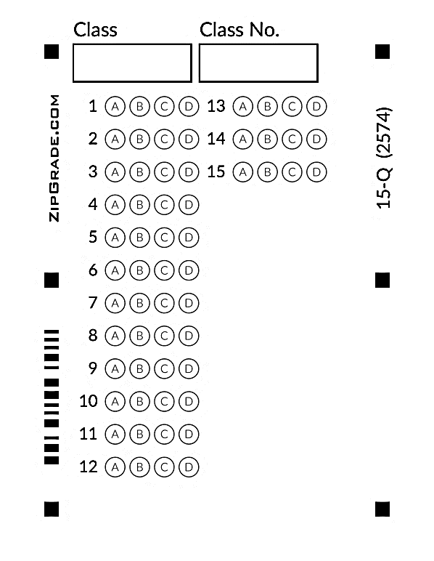

Consider the event "when Canvas1.Flung" in App Inventor 2 (Refer to Figure 1), which of the following parameters will be changed when the user's finger action is faster?

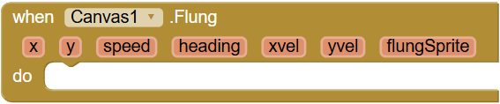
Figure 1

A. x
B. y
C. heading
D. speed

Which of the following component in App Inventor 2 include the property "Picture" or "BackgroundImage"?

(1) Ball
(2) ImageSprite
(3) Canvas

A. (1) and (2) only
B. (1) and (3) only
C. (2) and (3) only
D. (1), (2) and (3)

Consider the component "Canvas" in App Inventor 2, which of the following is the position of the origin?
A. At the top-right hand corner of the Canvas
B. At the top-left hand corner of the Canvas
C. At the bottom-left hand corner of the Canvas
D. At the bottom-right hand corner of the Canvas

Consider an "ImageSprite" on a "Canvas", which of the following directions of movement of the "ImageSprite" is correct when the value of "Heading" is equal to 0?
A. Right
B. Up
C. Left
D. Down

Consider the game "Mini-golf" in App Inventor 2, which of the following is the correct description of the component "Clock"?
A. To simulate the slow-down effect of the golf ball on the grass land.
B. To count the number of "flung" actions of the player.
C. To calculate the scores of the player.
D. To control the animation of the golf ball.

In Figure 2, an "ImageSprite" on the "Canvas" moves along the arrow. Which of the following is the correct value of "Heading" of the "ImageSprite"?
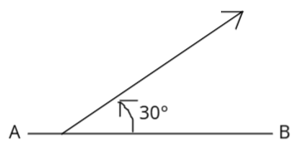
Figure 2
A. -30
B. 30
C. 60
D. -60

Consider developing a mobile app with App Inventor 2, which of the following events should be used for setting the starting values of all components and variables?
A. when Screen1.BackPressed
B. when Canvas1.Flung
C. when Screen1.Initialize
D. when Canvas1.Touched

Consider the game "Flappy bird" as shown in Figure 3. The player should control the bird moving "UP" and "DOWN" to dodge the obstacles. In this game, we should use the event
"when Canvas1.Dragged" as shown in Figure 4. Which of the following is the correct instruction for moving the bird up and down?

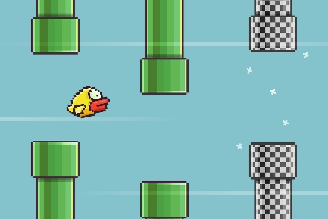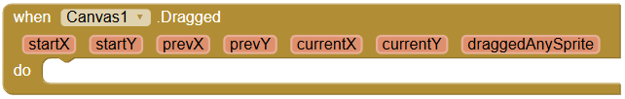
Figure 3 Figure 4
A. set Bird1.X to get CurrentX
B. set Bird1.X to get startX
C. set Bird1.Y to get CurrentY
D. set Bird1.Y to get startY

Consider the game "Space Invader" in App Inventor 2, which of the following instructions can hide the image sprite "Bullet" before starting the game?
A. set Bullet.Enabled to true
B. set Bullet.Visible to true
C. set Bullet.Enabled to false
D. set Bullet.Visible to false

Consider using the image classifier of "Teachable Machine", which of the following descriptions is the correct description for improving the accuracy of the AI model?
A. Use more irrelevant images to train the AI model.
B. Use less irrelevant images to train the AI model.
C. Use less relevant images to train the AI model.
D. Use more relevant images to train the AI model.

Which of the following expressions can random an integer from 51 to 100?
A. random integer from 1 to 100 - 50
B. random integer from 1 to 50 + 50
C. random integer from 101 to 150 - 100
D. random integer from 101 to 150 + random integer from 1 to 50

Which of the following blocks represents the situation below?

When the image sprite "Dog" collided with a ball "RedBall",
the value of the label "Score" will be deducted by 1
A. 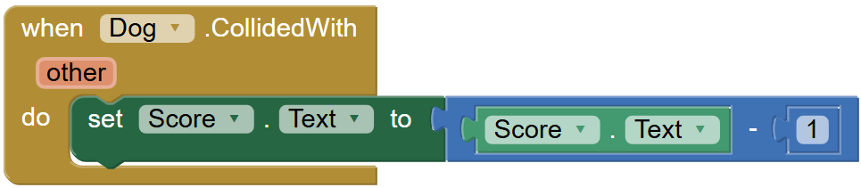
B. 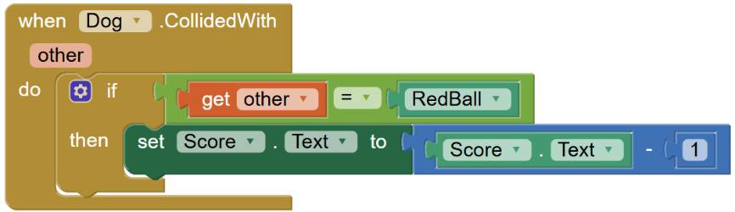
C. 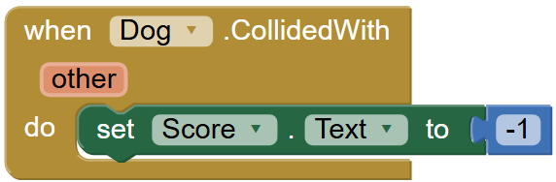
D. 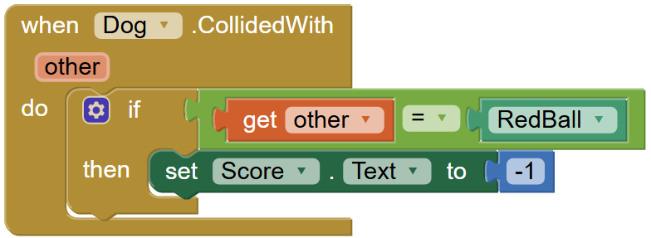

Figure 5 shows the properties of the component "TMIC", which is a teachable machine image classifier. Which of the following is the correct value of the properties "UrlModel"?

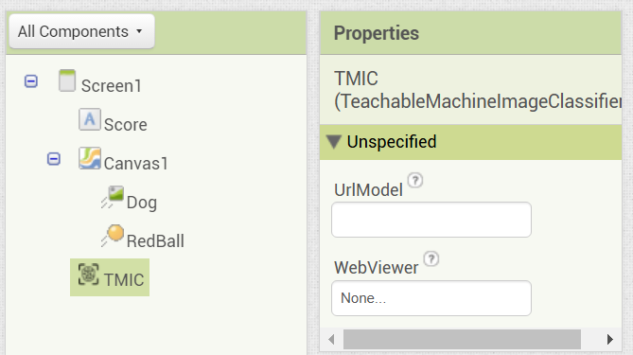
Figure 5
A. The URL of the model trained in the website "https://teachablemachine.withgoogle.com/".
B. The URL of the website of App Inventor 2.
C. The URL of the website of Carmel Holy Word Secondary School.
D. The URL of the website of this app.

In Figure 6, "WebViewer" is one of the properties of the component "TMIC", which is a teachable machine image classifier. Which of the following is the correct function of the property "WebViewer"?


Figure 6
A. It allows the user to assign a web browser component for showing the camera data.
B. It allows the user to assign the default web browser of Windows, e.g. Google Chrome.
C. It allows the user to open a new web browser for running the app.
D. It allows the user to open a web page within the app.

Figure 7 shows the layout of "Screen1". Which of the following is the correct component structure?

Horizontal Arrangement1

Vertical
Arrangement1
Vertical
Arrangement2
Vertical
Arrangement3
Figure 7
 | A. HorizontalArrangement1  VerticalArrangement1  VerticalArrangement2  VerticalArrangement3 | C. HorizontalArrangement1  VerticalArrangement1  VerticalArrangement2  VerticalArrangement3
 | B. HorizontalArrangement1  VerticalArrangement1  VerticalArrangement2  VerticalArrangement3 | D. HorizontalArrangement1  VerticalArrangement1  VerticalArrangement2  VerticalArrangement3

Section B: Short Questions (30 marks)
All answers should be written in the spaces provided.

1. Mr. Chan wants to develop a mini game "Snooker Practice Game" as shown in Figure 8.

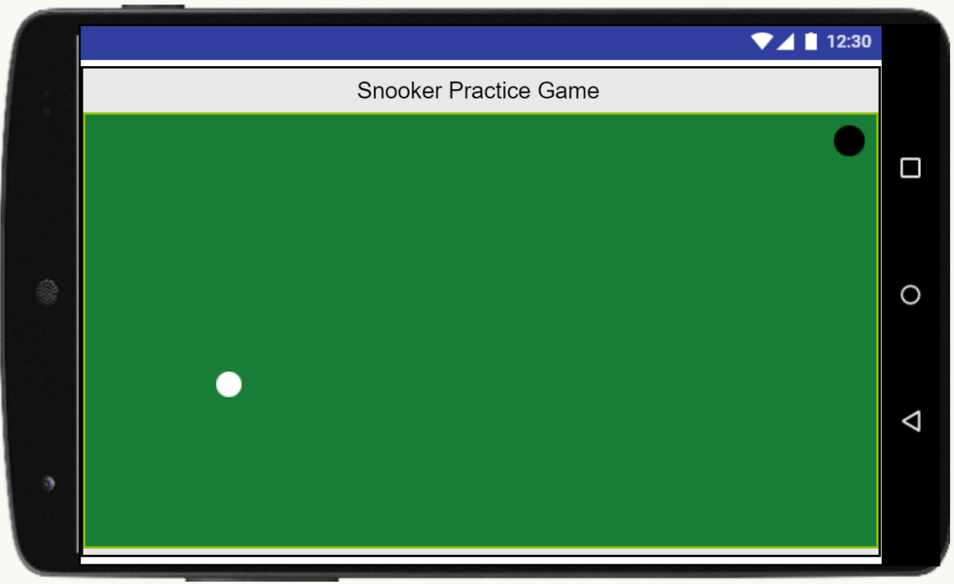
Figure 8

(a) In the game, there are 6 components. They are "Screen1", "VerticalArrangement1", label "Title", canvas "Table", ball "Hole" and ball "WhiteBall". Write down the correct component names in the boxes provided below to complete the structure of the app.
("Screen1" and "VerticalArrangement1" are provided as examples)

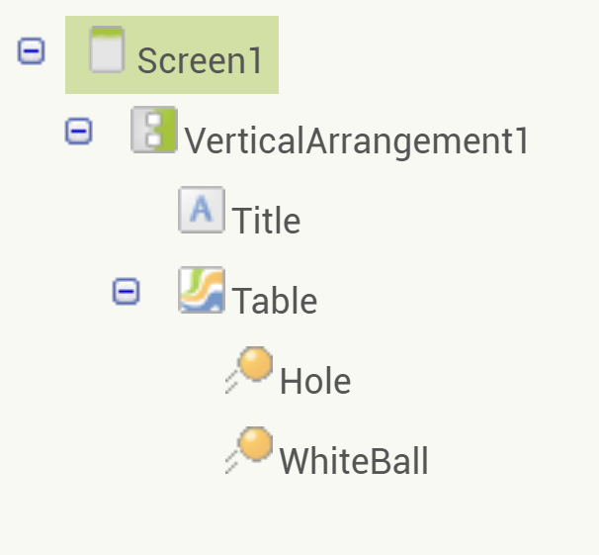
(i)
(ii)
(iii)
(iv)
(4 marks)

(b) Before the game starts, the following settings should be finished:
(i) The white ball will be placed to the coordinates (10, 300).
(ii) The hole will be placed to the coordinates:
x-coordinate = random integer from 0 to 580;
y-coordinate = random integer from 0 to 250
Write down the blocks in the event "when Screen1.Initialize".

Blocks provided:
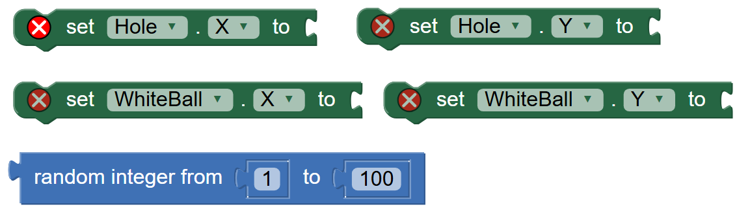

When Screen1.Initialize
do

(8 marks)

(c) Write down the meaning of the blocks in Figure 9.

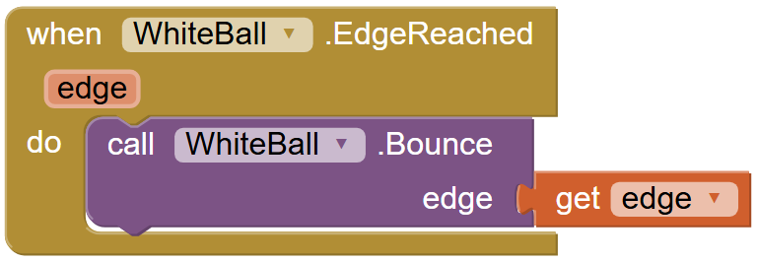
Figure 9

(2 marks)

In Figure 10, the blocks control the white ball to move to the same direction as the user's fling action, and the speed should be set to 30.

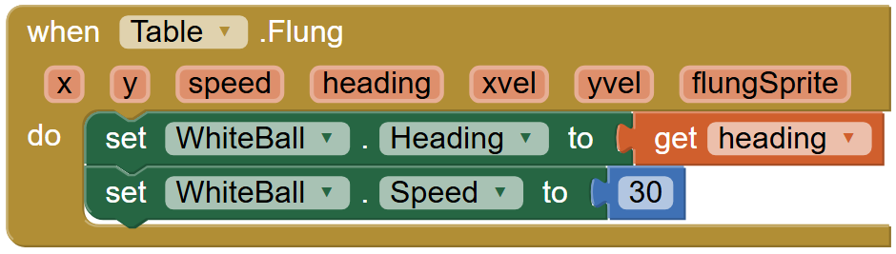
Figure 10

(d) Complete the event "when WhiteBall.CollidedWith" below to finish the following actions:
if the white ball collides with the "Hole",
- Set the x-coordinate of "Hole" to 100
- Set the y-coordinate of "Hole" to 50
- Stop the movement of the "WhiteBall"

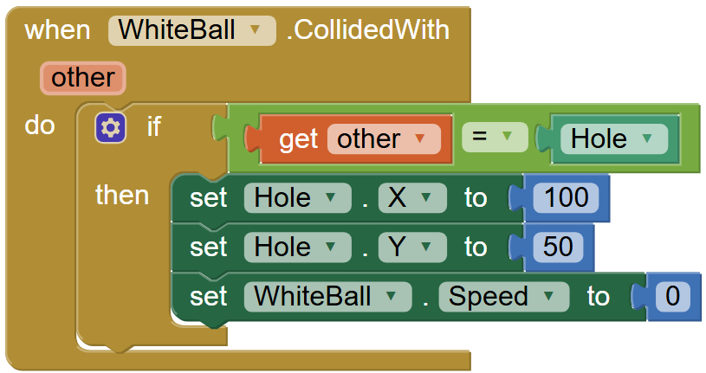
(vi)
(iv)
(iii)
(ii)
(v)
(i)

Write down the keywords or values in the following table.
(i) | (ii)
(iii) | (iv)
(v) | (vi)
(6 marks)

2. Peter designs an app with computer vision using "Teachable Machine".

  - In the app, once the user clicks the "Button1", the teachable machine image classifier "TMIC" will start capturing and classifying a frame from the camera. Write down the program in the spaces provided below. Some blocks are provided in Figure 11 for reference.

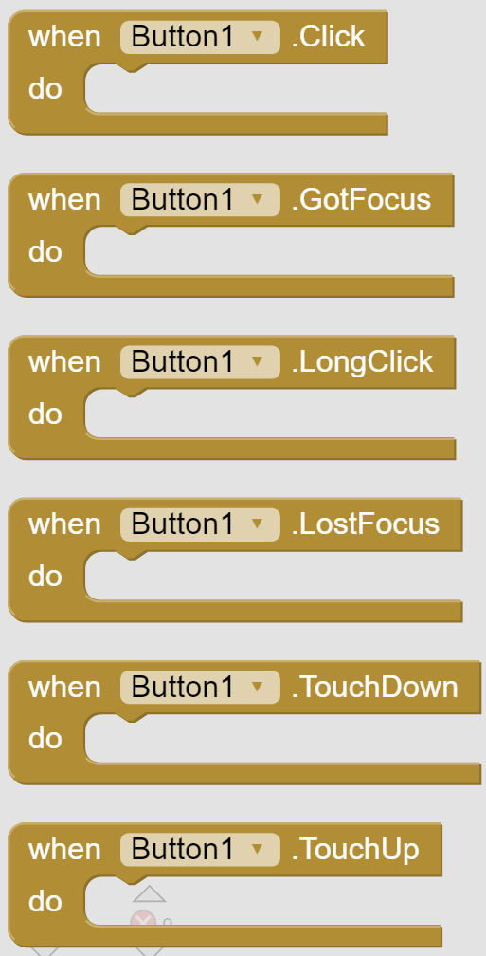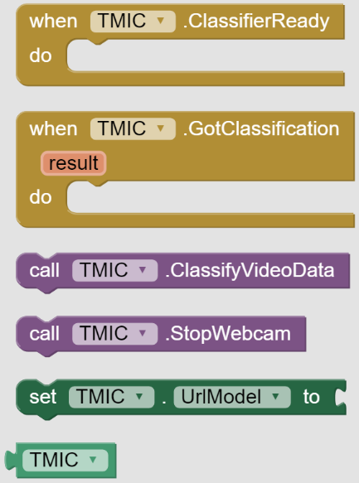
Figure 11

(2 marks)

(b) Peter wants to develop the computer vision app to classify between "Red" and "White". He prepares two color boards for training the model.

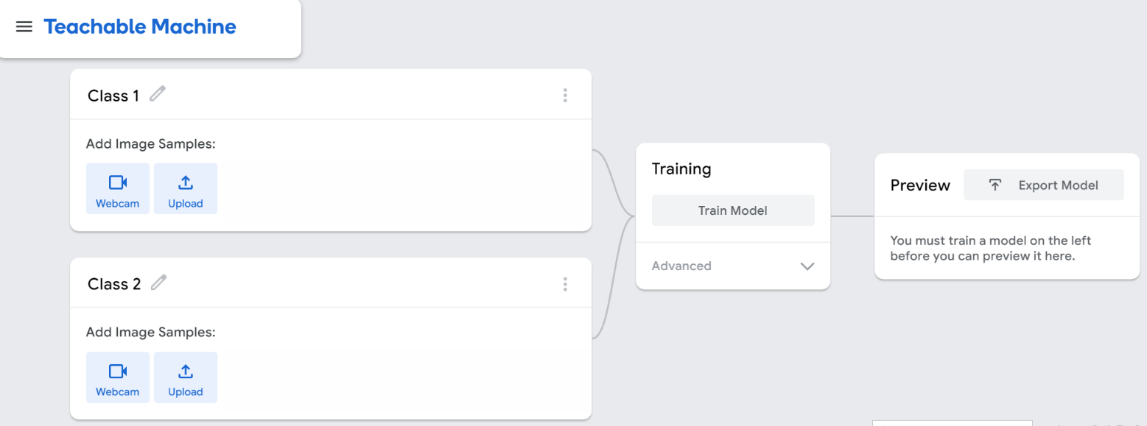
Figure 12

(i) In Figure 12, the default class name is "Class 1" and "Class 2". Write down the proper class name in the table below.

Default class name | Rename to …
Class 1
Class 2
(4 marks)

(ii) Figure 12 shows the user interface of the Teaching machine. Write down the steps for generating the model for classifying the color "Red" and "White". Start from renaming the class names.

1. Rename the class names.

(4 marks)

End of Paper

2024-2025 Term 1 S3 CMP Examination
Suggested Answer
Section A: @ 1mark
DCBAA BCCDD BBAAC

Section B:
1 (a) (i) Title (1)
(ii) Table (1)
(iii) Hole (1)
(iv) WhitBall (1)

(b) When Screen1.Initialize
do
set WhiteBall.X to 10 (1) Statement; (1) Value
set WhiteBall.Y to 300 (1) Statement; (1) Value
set Hole.X to random integer from 0 to 580 (1) Statement; (1) Values
set Hole.Y to random integer from 0 to 250 (1) Statement; (1) Values

(c) The white ball will bounce against the edge when it hit any one of the edges. (1), (1)
(copy the blocks directly gets 0 marks)

(d) (i) Hole (1)
(ii) X (1)
(iii) Y (1)
(iv) 50 (1)
(v) Speed (1)
(vi) 0 (1)

2. (a) when Button1.Click (1)
do call TMIC.ClassifyVideoData (1)

(b) (i) Class 1 Red (2)
Class 2 White (2)

(ii) 1. Rename the class names.
2. Capture or upload the photos of red card. (1)
3. Capture or upload the photos of white card. (1)
4. Train the model by clicking the button "Train Model". (1)
5. Export Model and get the URL of the model. (1)

